**The night of yesterday** struck Jack the Ripper again. The murder found place in the center of London. It was close by the church of the prostitutes.

**The Story**

**Yesterday** was a normal night in London people were going to their home or were going to friends. It was very overcrowded. Some police were chasing robbers. People were getting drunk and smoking in café’s.

Many men and woman were walking on the streets. A group of friends were walking together. The group were 2 men and 3 women were 2 women were pregnant. One of the pregnant women drunk to much so she needed to vomit so she went into a dark small side street. The other friends just were walking further. After some time they realized that she never came back. They walked back to the place where they have last seen her. When they were back to the place they searched around the place searching every street. Then one of the friends found a body in a dark small street. The friend shouted to the other friends that he found a body. The other friends came to the spot. Then they found out that their friend died.

**The police** have searched the body it appears that the body was from the friend. Her name was Jessie. She was 25 years old. She worked for a hospital in London. She had 2 children and a husband. She was loved by her whole family, work, friends.

**The murder** looks like the work of Jack the Ripper. Jack the ripper is a serial killer here in London. He has killed several woman in this city. He is a unknown killer but he did wrote some letters to some people that was signed with Jack the Ripper so that’s why we name him Jack the Ripper. Jack the Ripper also send kidneys with the letters. Several people said that they were Jack the Ripper but that was all a lie.

**We only know** that Jack the ripper wears a top hat, a coat that looks like Dracula’s cloak. We estimate that he is a man between the age of 20 and 40. He possibly doesn’t like women. He might look like this but it is not confirmed.

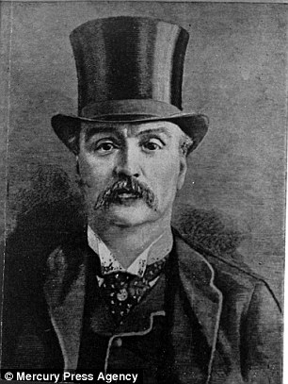

**Alois Andrews**

**The detective** Alois Andrews is currently searching for any clues of the murder. I asked Alois Andrews a few questions of what they already know. This is what I got to know. Jessie was not the only one murdered there was also somebody else murdered but dropped in a trashcan. They both got murdered the same way. Their kidneys got sliced out of their bodies. They both have cuts of a knife in their bodies. The time that Jessie possibly have been murdered was 10:25PM and the other body at 8:37PM.

After the murder the major got a letter with a kidney. In the letter was the following text. “I just have killed some women and I won’t stop I will cut through their throats and get their kidney’s out of them you will hear from me later.” Signed by Jack the Ripper.

**We don’t know** if anyone has seen any of the murders if so we want that you say it as soon to the detectives so they can continue to find Jack the Ripper.